Practical no. 24
Name :- Danish Altaf Solkar Enrolment no. :-24111590805
Class :- CO3K – B Subject :- DMS
Aim:- Create Procedure and stored procedures for Modularity

Program :-
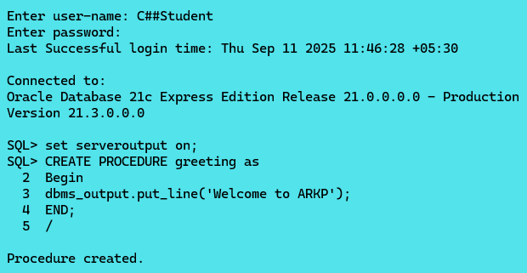
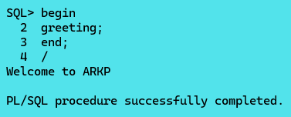

Program :-
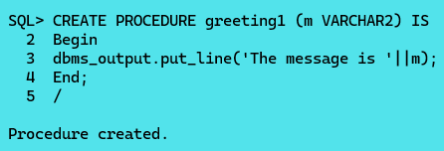
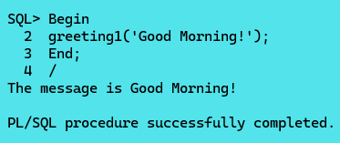

Exercise :-
Program :-
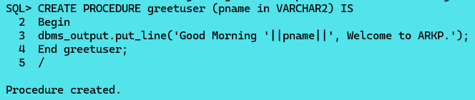
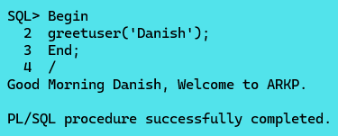
Program :-
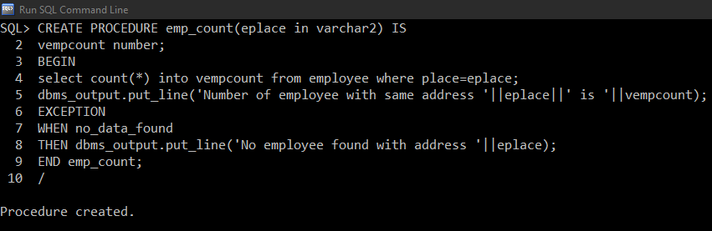
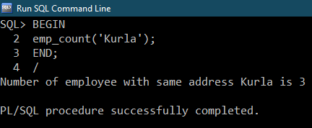

Program :-
